Sweet Hunter: The Complete Poems of St. Teresa of Ávila

A New Translation with Commentary

By Dana Delibovi
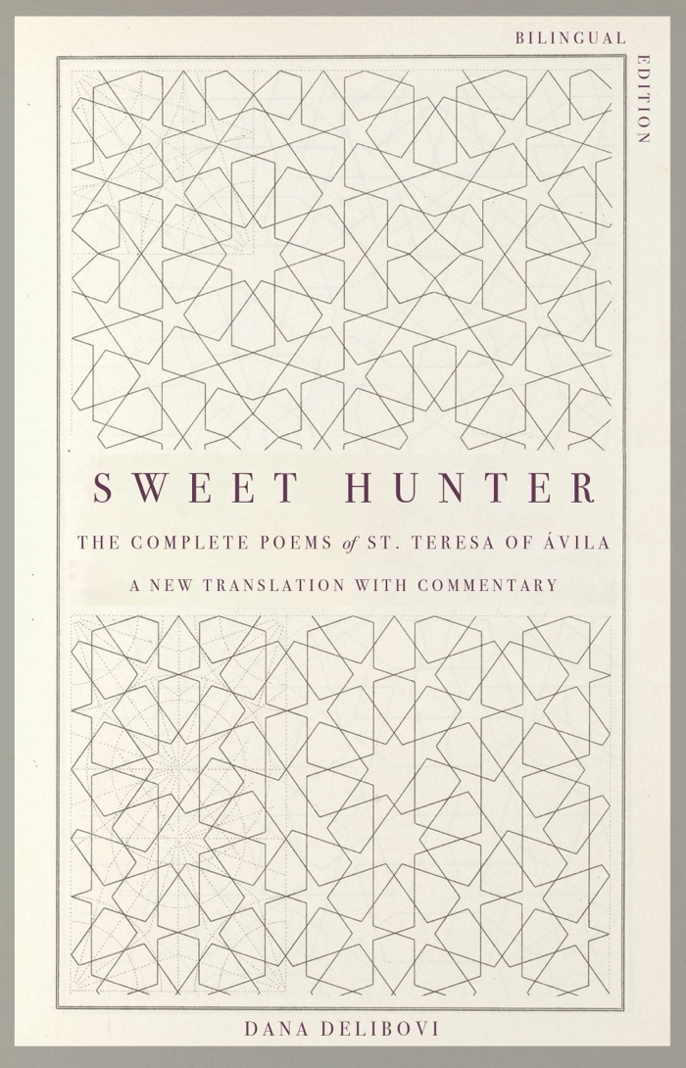
Sweet Hunter: The Complete Poems of St. Teresa of Ávila is Dana Delibovi’s collection of translations and essays. Monkfish Book Publishing will release the book on October 15, 2024—St. Teresa’s feast day.

Teresa of Ávila (1515–1582) was a complex woman: a mystic and monastic reformer; an artist and proto-feminist; a philosopher with a penchant for paradox. St. Teresa speaks to the spiritual longing of our times. She invites us to find peace in the midst of turmoil.

Delibovi’s new translation of Teresa’s poetry—the first by a woman translator—is rendered in contemporary English free verse with an ear to the saint’s famously conversational tone. Original essays by the translator establish the context of the poems, their motifs, and their craft. These well-researched essays are also deeply personal, as Delibovi shares the journey of the heart that led her to complete the book. Sweet Hunter captures in English all the spiritual vigor of Teresa’s unique poetic voice. Teresa walked a path of grace, and her poetry lights this path for all of us.
ISBN: 978-1-958972-49-6. Available for preorder,
https://www.monkfishpublishing.com/products-page-2/christianity/sweet-hunter/

From “About Those Words, ‘My Beloved is Mine’ ” in
Sweet Hunter: The Complete Poems of St. Teresa of Ávila

When the sweet Hunter  shot me and left me wounded,  when my soul lay panting  in those tender arms, | to balance out the cost  of a new life, I took this trade:  my Love belongs to me,  and I belong to him.
continued…

About Teresa of Ávila

Teresa de Jesus (Saint Teresa of Ávila, 1515–1582) was a nun, theologian, philosopher, poet, and mystic, who reformed the Carmelite Order and founded fourteen convents throughout Spain. Described in her day by the Papal Nuncio as “restless, pacing, disobedient, and stubborn,” Teresa needed all those characteristics on the road to her canonization (1622) and proclamation as the first woman to be named a Doctor of the Church (1970). Teresa wrote prolifically, across multiple genres. Her memoir, The Life of Teresa de Jesus, rivals Augustine’s Confessions as a chronicle of religious and spiritual awakening. She also wrote a philosophical treatise, Interior Castle; didactic volumes for the Carmelite Order, The Way of Perfection and The Book of Foundations; and numerous meditations, letters, exclamations, and theological observations. Teresa also wrote poetry throughout her life, of which 31 poems survive. Her poetry encapsulates the broad range of her interests and achievements—from monastic education to mystical experience.

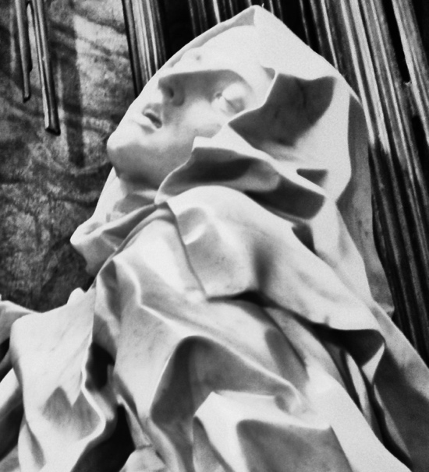

Gian Lorenzo Bernini. Detail from “The Ecstasy of St. Teresa.” 1652. In the public domain.

continued…

About Dana Delibovi

Dana Delibovi is a poet, essayist, and translator. She began translating the poetry of St. Teresa of Ávila in 2019, after raising a family and retiring from a 45-year hybrid career as an advertising copywriter and instructor of philosophy. Her translations and commentary are collected in her book, Sweet Hunter: The Complete Poems of St. Teresa of Ávila. A selection of Delibovi’s translations from Teresa and her original prose about the saint have appeared in Presence: A Journal of Catholic Poetry, U.S. Catholic, After the Art, Confluence, Catholic Poetry Room, and an anthology from Word on Fire. Delibovi's writing has also appeared in Apple Valley Review, Bluestem, Noon, Psaltery & Lyre, Salamander, and many other journals. She is a 2020 Pushcart Prize nominee, a 2020 Best American Essays notable essayist, and co-winner of the 2023 Hueston Woods Poetry Contest. Delibovi is Consulting Poetry Editor at the literary e-zine Cable Street.



Dana Delibovi

Praise for Sweet Hunter

A gorgeous collection. Dana Delibovi’s translations and the essays that accompany them are thoughtful, inviting, insightful, and rich. Through them, Saint Teresa’s passionate words pierce through the page and bloom beautifully in the reader’s mind – and heart. Lovers of her poems will return to this book again and again.

—Randon Billings Noble, author of Be with Me Always: Essays and editor of A Harp in the Stars: An Anthology of Lyric Essays

Dana Delibovi writes in her very informative introduction to Sweet Hunter that “the mystical and the practical, as different as they seem, are elided in Teresa’s work, because both involve concrete experiences, not abstract concepts.” In her important translation of St. Teresa’s complete poetry, Delibovi remarkably demonstrates the entwined presence of these two tendencies in her concrete, accurate and stunning versions. Saint Teresa has, at last, found an English translator who has deeply penetrated the poet’s essence, her revelatory reverence and rapturous beauty.

--Christopher Sawyer-Lauçanno, poet, essayist and translator, author of Night Suite, Remission, and A Continual Pilgrimage: American Writers in Paris, 1944-1960.

If, as Joseph Brodsky once declared, the translator of poetry is a rival to the original poet, then Sweet Hunter: The Complete Poems of St. Teresa of Ávila finds poet, critic, and translator Dana Delibovi answering the challenge with full commitment. The rivalry here, however, is not one of competing techniques. Rather, poem by poem, Delibovi renders Ávila’s vision with a clarity faithful to the original but which works in tones and nuances that speak to our contemporary moment. This tension across language and time presents parallel efforts and passions. Delibovi’s notes which accompany each poem add further depth and provide a running commentary where Delibovi’s own voice mixes with that of previous translators, ultimately creating a lively meditation filled with insightful details from Ávila’s life and practice. This layered approach is apt in engaging with the work of a mystic, work shaped by urgency and faith as much as craft. What Delibovi has gifted us is much more than a selection of poems: it’s a wholly distinct poetic journey.

—José Angel Araguz, author of Rotura and Ruin & Want

The power and fluidity of Dana Delibovi’s superb translations spark the poems of St. Teresa of Avila into the 21st century. Sassy and ebullient (especially in her advice to her convent sisters) yet profoundly spiritual, Teresa has found an ideal translator in poet Delibovi, who holds the seeming contradictions of St. Teresa’s mystical yet physical nature in her capable hands. Sensuous yet strict, feminist yet practical, Teresa navigated a sexist, hierarchical world with brilliance. Delibovi found herself both connected and inspired as she read, re-read, and began translating these poems, then organizing them for the contemporary reader into Sweet Hunter: The Poems of St. Teresa of Avila. The Delibovi translation opens a shining portal to poems that are fresh and electric today.

—Molly Peacock, author of The Widow’s Crayon Box: Poems.

Dana Delibovi’s luminous translations of St. Teresa’s poetry are as imaginative as they are faithful, deftly balancing the mystical with the pragmatic, the exuberant with the introspective, the sensual with the soulful. Passionate, visceral, yet warmly conversational, these stunning translations reunite us with our own yearnings even as they introduce us, with great depth and musicality, to St. Teresa’s pathbreaking poetry.

—Nandana Dev Sen—Author, actor, activist. Translator of Acrobat: Poems by Nabaneeta Dev Sen

Dana Delibovi’s new English translation of the poems of Saint Teresa of Ávila provides the reader not only with an occasion to contemplate through Teresa’s vision the meaning of Christ on the Cross, but also to become a carillo, one of Teresa’s dear addressees in the poems, feeling through her voice an intimacy with the divine and, therefore, achieving a kind of mysticism—a mysticism that leads the reader to the ultimate goal of Teresa’s art—that we not fear death.

—Mary Ann B. Miller, editor-in-chief of Presence Journal and professor of English, Caldwell University

The immediacy of these new translations is such that the prayers, dialogues, and instructions of Saint Teresa of Ávila read as if they already resided, unuttered, in our minds. Dana Delibovi’s rendering of these works—by turns mystical, sensual, and practical—removes all sense of distance between Teresa’s life and our own, permitting her voice to resonate with an astonishing intimacy. This fusion of the idiom of Catholic faith with the manifest language of a poet’s soul stands as a revelation unto itself.

—Eric Darton, author of Free City and Divided We Stand: A Biography of New York's World Trade Center

